Task 2

Date*: -* 22/07/2025 & 29/07/2025

Aim*:* - Execute the following network commands like

* Ipconfig
* tracert
* telnet
* neths
* ping
* nslookup
* netstat

Procedure:

Step 1) Launch the Cisco Packet Tracer. Double-click the Cisco Packet Tracer icon on your desktop or find it in your application list and open the program

Step 2) Create a simple network topology;

* Add Devices

Add router (ISR4331) and two switches(2960-24TT). Drag and drop the router and the switches from the device list onto the workspace. Drag and drop two PC’s (PC-PT) onto the workspace as well.

* Add connections

Now, by using the connection tool, connect the devices. Connect one PC (PC0) to the switch (Switch0) using the copper straight-through cable. Similarly, connect the second PC(PC1) to the second switch (Switch1). Now connect the switches to the router using a straight-through copper cable.

*The network topology should be like the figure below

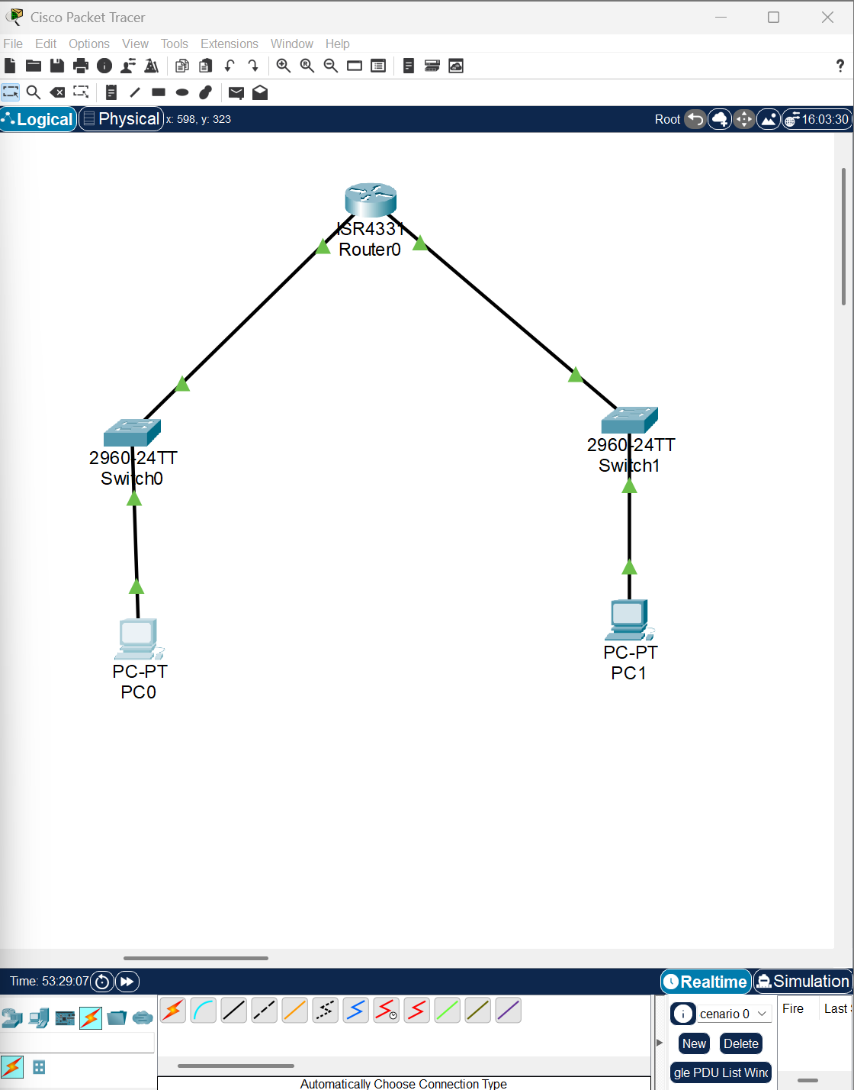

Step 3) Configure the devices

* Router

First, configure the router by clicking on the router and then navigating to the config tab. Then, after opening the config tab, select GigabitEthernet0/0/0. After selecting the GigabitEthernet0/0/0 interface, the IPv4 address should be 192.168.1.1, and the Subnet Mask should be 255.255.255.0, and select the tick mark next to On to configure.

Similarly, for GigabitEthernet0/0/1 type IPv4 address as 192.168.2.1 and the Subnet Mask should be 255.255.255.0, and select the tick mark next to On to configure.

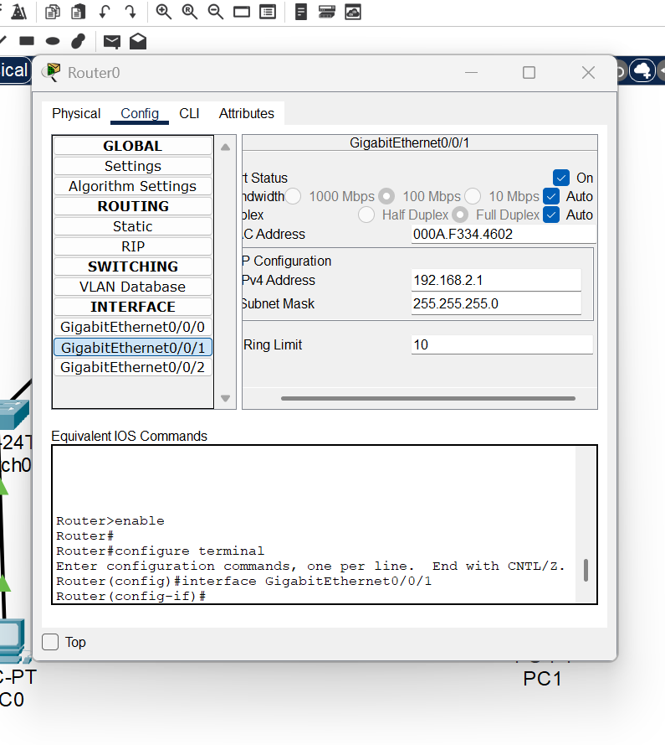

* PC’s

Next, click on the PC0 and then select the Desktop tab. After navigating to the desktop tab, you will see a list of symbols along with their names beneath them. Select the IP configuration and click on it. Next, in the IP Configuration section, type the IPv4 Address as 192.168.1.2. Then the subnet mask will be 255.255.255.0. Then, in the Default Gateway type 192.168.1.1.

Similarly, repeat the process for the PC1 with the IPv4 address of 192.168.2.2. Then the subnet mask will be 255.255.255.0. Then, in the Default, assign the IPv4 address which we have given for GigabitEthernet0/0/1, which is 192.168.2.1.

*Now we have established connections between the PCs and the router

Step 4) Command Prompt

Click on the PC0 and then select the Desktop tab. Now select the Command Prompt icon.

Now type the commands.

* ipconfig

This command displays all the current PCs' IP network configurations and all the DHCP and DNS settings. After typing the ipconfig command in the command prompt, you will see the following details, as shown in the figure below.

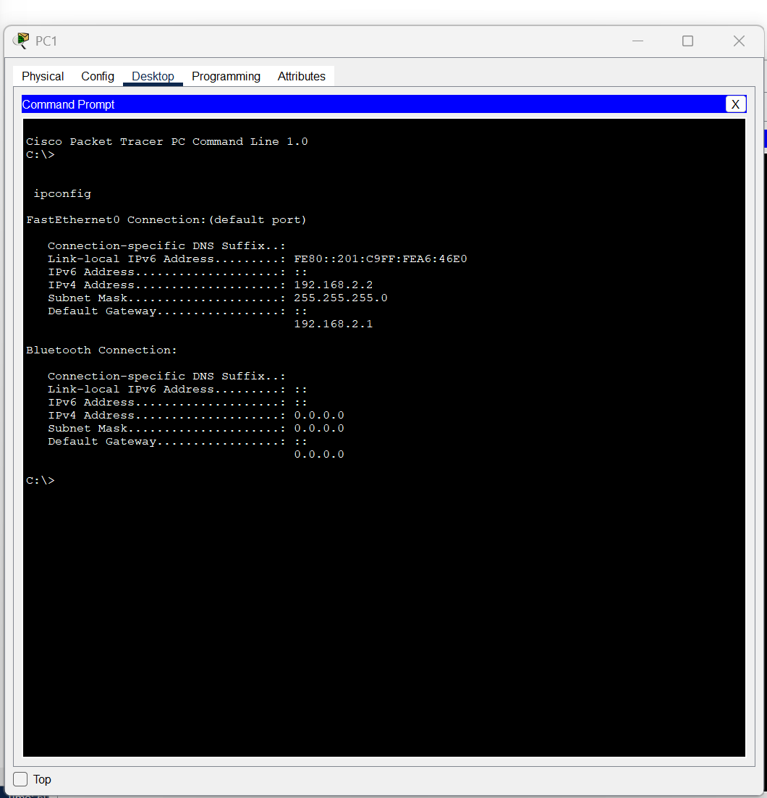

* tracert

The tracert command (also known as traceroute on non-Windows systems) is a network diagnostic tool used to trace the path that packets take from your computer to a specified destination. It identifies the routers or "hops" along the way and the time it takes for each hop, helping to diagnose network issues and understand the route packets are taking.

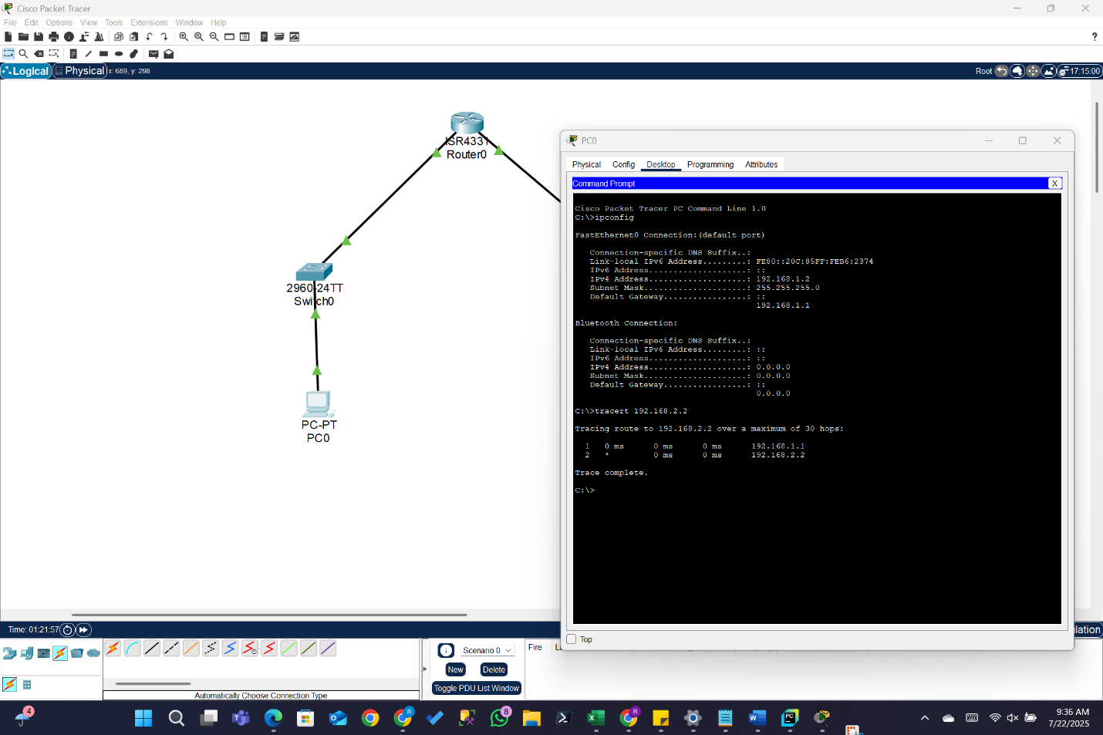

* telnet

The telnet command serves as a client for the Telnet protocol, primarily enabling text-based communication with remote computers. Its main purposes include:

In order to execute the telnet command, we first have to configure the router.

🡪 Configuration of router: -

* Click on the router
* Go to the Config Tab
* Select the interface connected to switch 1, in this case, GigabitEthernet0/0/0, and assign the IP address 192.168.1.1, and the subnet mask should automatically be 255.255.255.0.
* Similarly, click on the GigabitEthernet0/0/1 and assign the Ip address 192.168.2.1, and the subnet mask should automatically be 255.255.255.0.
* Now go to the CLI tab and type the following commands, or check if the following commands are there or not

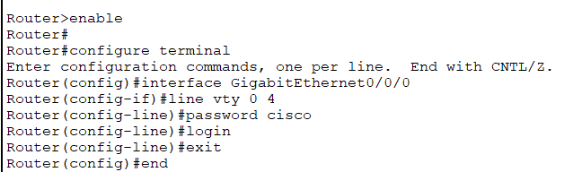

Now, go to the command prompt in PC0 and type the following command

* telnet 192.168.1.1 23

It should come as User Access Verification, and then it will ask for the password, which we have given in the above command line number 7, which is cisco

Now type the password, and then it should enable the router like the following image

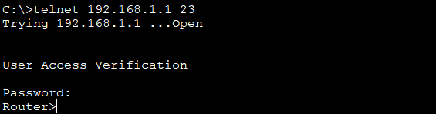

Now, another way we can execute the command is by directly typing the command on the CLI. You should see the following output

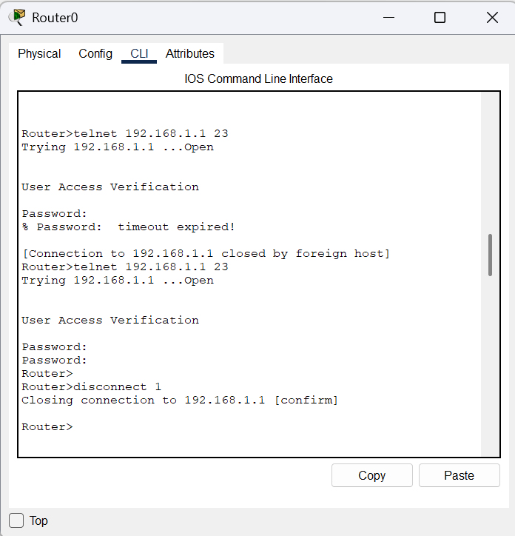

* Router Configuration and Brief IP Interface

This command is a scripting utility that allows you to display or modify the network configuration of a computer

Type the following command into the router CLI

Show IP interface brief

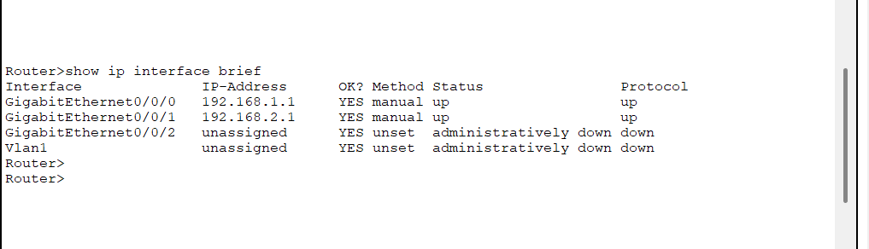

* Ping

The primary purpose of the ping command is to test network connectivity and measure the round-trip time (RTT) for data packets between a source device and a specified destination host.

To execute the ping command, we have to open the command prompt in PC0 and type the following command in the command prompt

: ping 192.168.2.2

After typing, you should get the following output

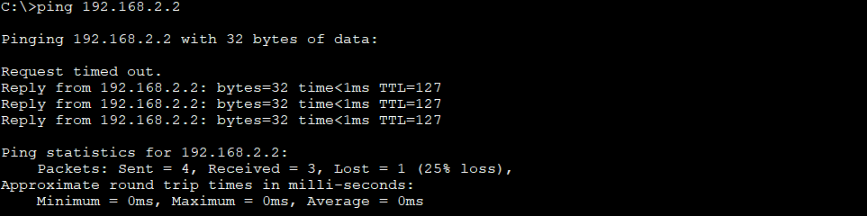

* nslookup

The nslookup command is a command-line utility used for querying Domain Name System (DNS) servers to obtain information about domain names, IP addresses, and other DNS records.

To execute the ping command, follow the steps below:

1. Add a server to the existing network topology (to act as a DNS server)
2. Connect the server to switch 0, similar to the image below

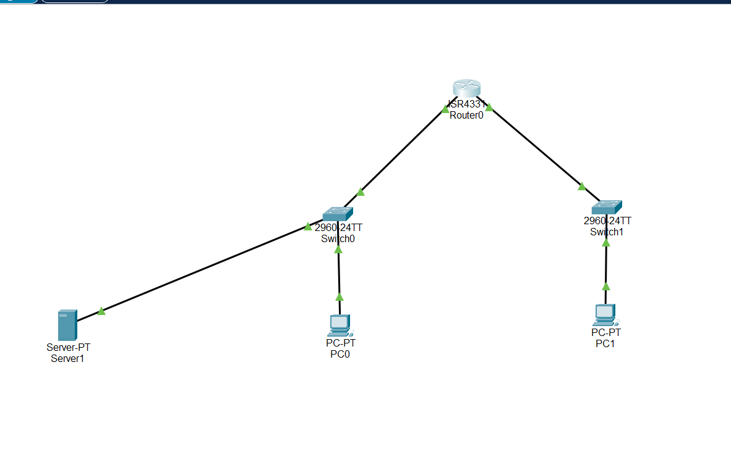

1. Now we have to configure the DNS server
2. Click on the server and click on the config tab. From the dropdown section, click on the FastEthernet0
3. Now assign the following IP address in the section IPv4 Address 192.168.1.3. The subnet mask should be 255.255.255.0
4. Now the default gateway should be 192.168.1.1
5. Now, go to the Services tab and from the dropdown section, click on the DNS
6. Now, in the DNS window, in the name section, type [www.google.com,](http://www.google.com) and in the address bar, type 8.8.8.8, and turn on the DNS server.

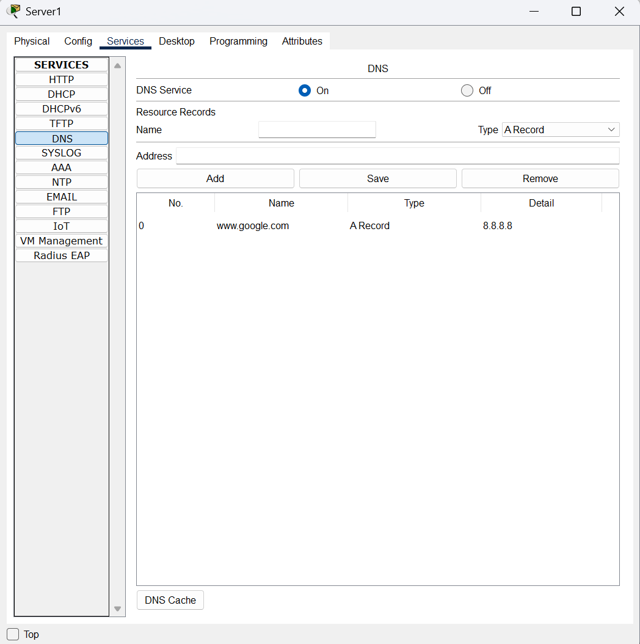

1. Now, open the command prompt in PC0 and type the following command

nslookup [www.google.com](http://www.google.com). You should be displayed with the following output

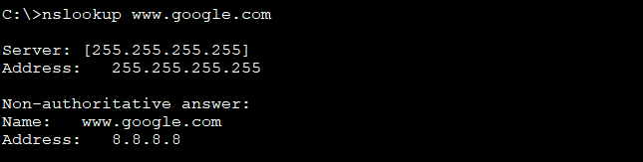

This indicates that the PC successfully queried the DNS server and resolved the domain name [www.google.com](http://www.google.com) to the IP address 8.8.8.8

* Netstat

This command displays network connections for the Transmission Control Protocol (TCP), routing tables, and a number of network interface and network protocol statistics.

The netstat command is used to display network connections, routing tables, interface statistics, masquerade connections, and multicast memberships.